# Thorough Research on predictive analytics and its implementation to develop an expenses support system for small business company

# Introduction

Modern business is totally dependent on data. Data is the new value and without it we are just some dumb baboons. But, raw data does not have any value; we need to generate value by extracting information from the raw data. Hence, data analysis is a much hyped topic today. Typically, data analysis means systematically applying statistical or/and logical methods in order to illustrate and describe, recap and condense, and evaluate data. Shamoo and Resnik (2003) explain different analytical procedures “*provide a way of drawing inductive inferences from data and distinguishing the signal (the phenomenon of interest) from the noise (statistical fluctuations) present in the data*”. To take it even further, we can mine the data in order to predict the future patterns of the business which leads us to the topic of predictive analysis.

Expense management is affecting business at the macro level. Example includes globalization. It not only influences expenses management but also increases the cost in many instances. Global Business Travel Association also estimates that there will be an increase in costs by 4% this year and suggests business to be prepared and address it as a general challenge. All of the challenges of expenses management can be easily addressed with the help of an expenses support system which helps to keep the costs in check. It also uncovers the where the money is going and give an idea to cut costs. It provides transparent visibility to overcome the difficulties in optimizing expenses and determine ROI for T&E costs.

To conclude, this dissertation aims to investigate on data prediction technology and its use to create an Expenses Support System that will allow the small business companies to manage their expenses that ultimately increases their overall profit.

# Aim

Through analysis on predictive analytics and its implementation to design and development of Expenses Support system for small business company

# Objectives

* Learn the advantage of data mining technology in today’s world
* Learn data visualization technology and implement it to display company’s expenditure details
* Learn to use most secured database technology i.e. oracle
* Focus on the benefits of data prediction in company’s overall business growth
* Create a decision support platform that will predict future expenditure/savings

**Keywords**

* Daily expenditure tracking
* Android application
* Possible solution to tackle budget
* Over budget Notification
* Decision making
* Budget enhancement
* Data security

# Justification

### Problem Statement

Budgeting day-to-day revenue and expense decisions are very hard. Mostly companies are unable to manage their budget over a month. They cannot make proper decision where to spend their money and where not to. Company faces problems in the end of month or every year when it comes to Expense management. Nobody knows which month ends with sufficient budget and which one month will require extra amount of money. Due to inefficient expenditure management, Company faces difficulties in many situations.

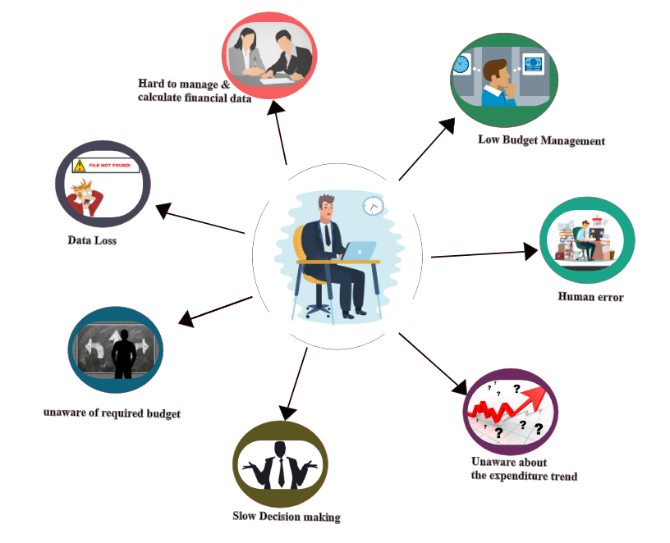

Figure 1: Problem specification

### Solution

Needless to say, it can be a stressful time without the proper system. This research will identify the advantage of data mining and its appropriate tools for your expenditure prediction. This application will be helping you to maintain your budget, predict your future expenditure so that you could be prepared, Notifies if you are out of budget, provides information about your past expenditure ratio and helps in faster economic related decision making etc. This application will be designed to keep your expenditure on track and pinpoint areas of improvement.

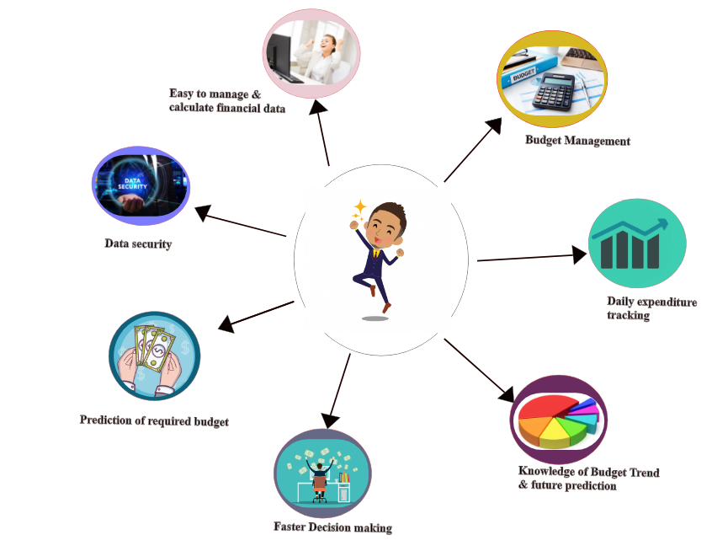

Figure 2: Solution providing by Expense management system

**Questions in financial prediction**

1. Prediction Possibility.

Is personal expenditure prediction for future decision taking is possible using current state data? Is it profitable of such data prediction?

*Method:*

If prediction is possible, State the methods best for performing it.

1. Security.

Is the predictive data is secured enough? Can we trust the application about our privacy concern? Is there any issue related to data backup and recove*r*y?

*Method:*

What is the security measure to ensure the data produced are safe?

1. Is there any advantage of data prediction for company expense management? Is there any trust to ensure predictive data can be used for company expense management?

*Method:*

If yes, how can this possibly help the company compete? What key innovation in predictive analytics has crowdsourcing helped develop?

1. Are there ethical issues raised in predictive analytics?

# Mini Literature Review

**Eric Siegel**, an author of ***Predictive Analytics*** reveals how predictive analytics works and how it affects to everyone every day. Prediction was, is and will be the ultimate power of the world taking examples from world war to today’s business society. Book clearly specifies the benefit of predictive analytics as consumers, as organization and also company sales. Prediction is power. He stated how big company secures a killer competitive stronghold by predicting the future destiny.

***Data Science for Business***, an author **Foster Provost** and **Tom Fawcett,** introduces fundamental principle used to walk through “data analytic thinking” necessary for extracting information from the piles of data. This book makes clear understanding of data mining techniques used in today. We can learn how company can participate in intelligently data science projects for long term company vision. Beside, this book make me clear understand about big data that can be used as business asset that requires careful investment if you’re to gain real value. We can lean concepts for actually extracting data knowledge too.

# Scope and Technical Challenges

In today’s business world, data is indispensable. Using of big data technologies to gain insights that can help in making strategic decisions is rising in today’s technological world. The massive amount of data produced in day to day transaction and examining these data sets to find patterns in it is vast. Using these data to predict the future will give information about the company. This can expose the company direction to profitability or loss making.

The use of data analytics by the company is enhancing every year. Making an application that will identify patterns, notifies expenses, create predictive patterns etc. will help organization in rapid growth. If your company want immediate real time data visualization, prediction and make faster decision then this research will help you to know appropriate technologies that can be used for mining your data and produce useful information.

# Research Plan

Methodology has great importance during research which ensures the research is carried out in scientific approach. If we are able to design right methodology, it would make our path easier to arrive at the conclusion of any problem. There are mainly two different types of methodology.

### Quantitative research methodology

Quantitative research methodology focuses on the figures during the experiment and mainly focus on questions “What”. Operating cost forecasts of company can be used in budgeting process and economic feasibility studies. Statistical data obtained will be used to for quantitative research of company and provide appropriate suggestion.

### Qualitative research methodology

Qualitative research methodology gives answers to why is the research carried out. This research will helps to know why people think, feel, react and behave in the way that they do using range of techniques. This research helps to obtain users feedback about the expense management system so that we can increase usability of application. (Kovalerchuk, 2009) Techniques like Qualitative interviewing, case study and Questioner can be used during research.

# Scope and Technological Challenges

## Developmental Methodology

There are many development methodologies to organize the process of developing software. This is a series of process used in software development. Development without proper methodology will make software development difficult because it will be hard to track development work done. Among the different methodologies available, agile development methodologies seems to be appropriate for this project.

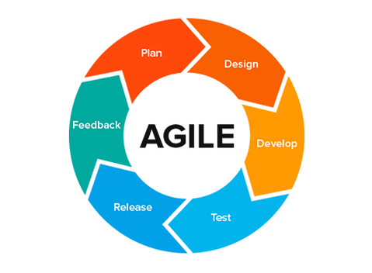

Figure 3: Agile development Methodology

As this is research project, we are unaware about the product to be built until end. Software development must be easily flexible enough to handle the changes. Agile Development methodology addresses perfectly end user’s need. During whole cycle, end user involvement is encouraged, providing transparency and visibility. This method is all about iterative planning, making easy step to adopt when requirements changes. (An Introduction To Software Development Methodologies, 2014)

Why Agile?

* High Product Quality

Each release is thoroughly test to ensure software quality is maintained.

* High End user satisfaction

Here end users are involved throughout the process which increases their satisfaction.

* Increased Project control

Daily sprint meetings and increase transparency helps to control project flow.

* Reduced risks

This methodology eliminates the chances of absolute project failure.

Statistics revels that on average, the time to market is 37% faster with efficiency of the team is increased with productivity higher by 16% that the average.

## Tools and Technology

There are many tools and technology in market and choosing best possible form them is a real tough. Some of the tools and technology that will be used for development of application are shown below:

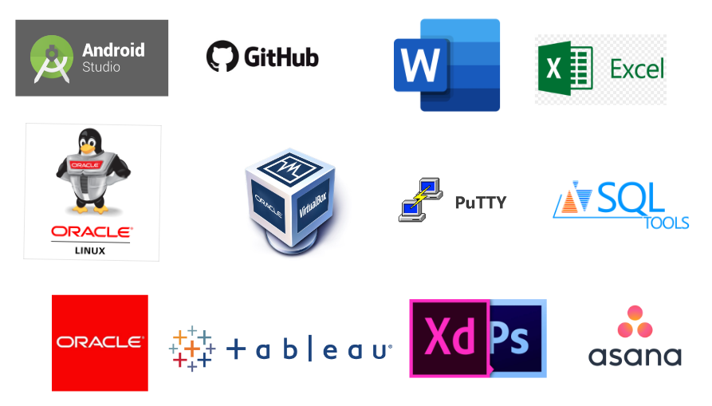

Figure 4: Tools used in Development

# Project Management

Project management is most important to bring leadership and direction to projects. Proper vision, removing roadblocks will help to complete project in time. WBS “Work Break Structure” is a technique which helps to broke down project into small chunk which helps to make project understandable the what, when, why and How of the desired result.

Also, I have used Time Estimation technique which will ensure the project will be completed in time. For good project management, accurate time estimation is important. Different milestones set to complete the project will help us to complete project in estimated time.

# Bibliography

*An Introduction To Software Development Methodologies*. (2014, 5 22). Retrieved 7 28, 2019, from https://www.alliancesoftware.com.au: https://www.alliancesoftware.com.au/introduction-software-development-methodologies/

Kovalerchuk, B. (2009, 1 19). *Data Mining for Financial Applications*. Retrieved 8 18, 2019, from researchgate.net: https://www.researchgate.net/publication/302371209_Data_Mining_for_Financial_Applications